Title: "Realm of Elements"

Overview:
"Realm of Elements" is a two-player perfect information strategy board game that takes place in a mystical world where players compete as powerful elemental mages seeking to harness the forces of nature and magic to gain control over the realm. The game combines elements of strategy, tactics, and spellcasting.

Components:
1. Game Board: The game board consists of a square grid with 8x8 cells. Each cell represents a specific terrain type, such as Forest, Mountain, Lake, and Plains.
2. Elemental Mages: Each player has a set of 5 elemental mage pieces, representing Fire, Water, Earth, Air, and a Spirit Mage. These pieces are uniquely shaped and colored.
3. Guards: Each player also has a set of 5 guard pieces, which play a protective role in the game.
4. Spells: There is a table of spells that players can cast during their turns. These spells are categorized into offensive, defensive, and utility spells.

Setup:
- Place the game board in the center of the table.
- Each player chooses a color and places their elemental mages and guard pieces on their side of the board. The setup is as follows:
x G G G G G x x
x F W S E A x x
- Spells: Every element has three spells, which can be cast using spell tokens. Both players start with 5 and get 1 more with every turn (except the starting player), and every 5 turns the addtion increases by 1.

Gameplay:
"Realm of Elements" is a turn-based game, and players take alternate turns. Each turn consists of two phases: Movement and Action.
Movement Phase:
During the Movement Phase, a player can move three of their pieces (elemental mage, guard) to an adjacent cell. Mages can move an addition tile when they start on their favorable terrain.

Action Phase:
During the Action Phase, the player can choose one of the following actions:
- Attack (1v1): The player selects one of their elemental mages and one adjacent enemy elemental mage to attack. Elemental mages can defeat other elemental mages of opposing elements instantly, even with a guard present. Guards can attack mages, but the mage will also die the other way around. After taking the piece of the board the attacker moves onto the square the defender used to stand on.
- Cast Spell: Players can use their spell tokens to cast spells, provided they have enough spell tokens (determined by the spell's cost). Each player can cast a maximum of two spells per turn (increases every 10 turns). They will be cast through the mage with the same element in a range of 2 in each direction (differes with the terrain they stand on).
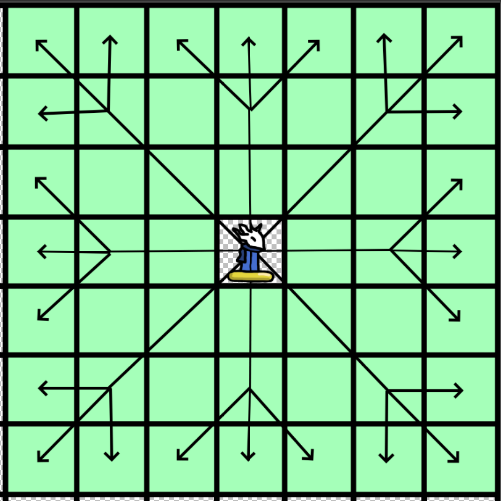
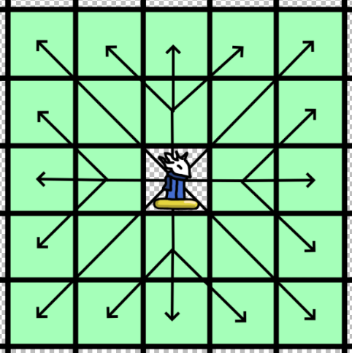
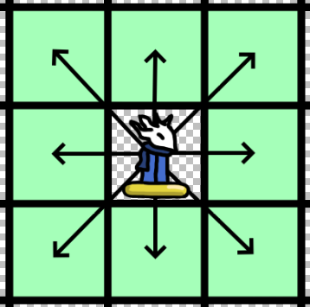
- Guard: Guards can protect adjacent elemental mages by intercepting attacks. If any enemy piece tries to attack an elemental mage protected by a guard, the guard is removed from the board instead of the mage. You also can’t cast spells through them (guard is standing between attacker and defender). This is the calculation table:

Special Rules:
- Terrain Effects: Increases/Decreases range of spells by 1 if the wizard stands on their strong/weak terrain. Increase the amount of tiles he mage can move by 1 if standing on their strong terrain at the start of the movement phase.
- Victory Condition: The first player to eliminate all their opponent's elemental mages or the opponent's Spirit Mage wins the game.

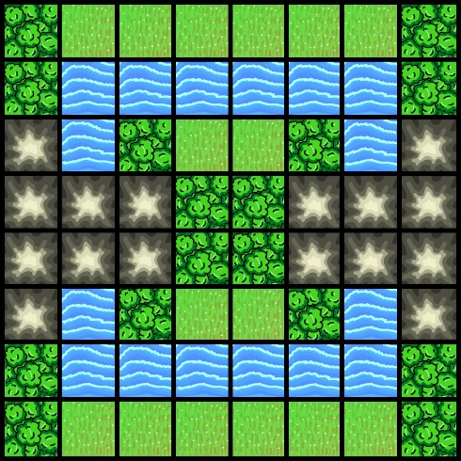
Example of a Fixed Board (Turn 90° for another one):
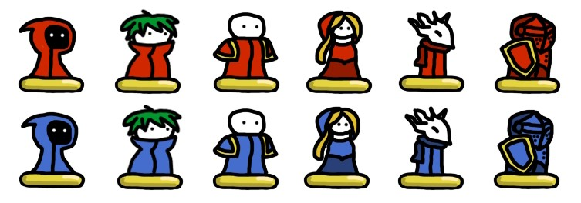
Fire Air Water Earth Spirit Guard
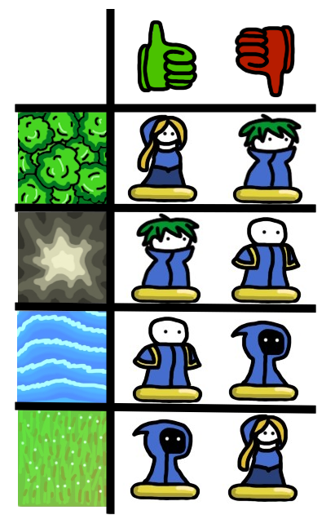
For attacking to kill directly with guards present:
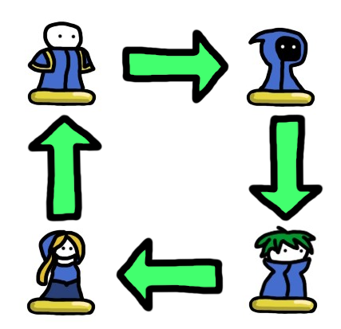

 | Fire Spells | Water Spells | Earth Spells | Air Spells | Spirit Spells
Attack:  Attack an opponents piece. | Fireball  Cost: 3  Effect: Kill the target give space Inferno effect for 1 turn. | Icy Spear  Cost: 2  Effect: Kill the target. | Rockslide  Cost: 3  Effect: Kill the target and make space unavailable for two turns. | Gale Force  Cost: 3  Effect: Kill the target and push back surrounding pieces by one. | Soul Siphon  Cost: 3  Effect: Kill the target and take one spell token from the oponent if they have at least 1 token.
Defense:  Defend the mage in question and one adjancend guard of choice. | Blazing Barrier  Cost: 2  Effect: Immune to attacks (not spells) for one turn. | Aqua Shield  Cost: 2  Effect: Immune to spells for one turn. | Stone Wall  Cost: 2  Effect: Immune to spells for one turn. | Aerial Shield  Cost: 2  Effect: Apply spell cast on mage on attacker as well, lasts for one turn. | Ethereal Shield  Cost: 2  Effect: Immune to spells for one turn.
Untility:  Apply an effect to pieces or the board. | Inferno  Cost: 4  Effect: 3 by 1 Area in which every piece dies that passes through, can’t be cast on full squares, lasts for two turns. | Tidal Surge  Cost: 4  Effect: Push back all pieces from range plus 2 by two spaces. | Tremor  Cost: 4  Effect: 2 by 2 area make pieces skip turn. | Zephyr Step  Cost: 3  Effect: Move to an adjancent tile. | Soul Swap  Cost: 3  Effect: Switch two of your own pieces.

Spell Tokens better neutral worse



